**Frameworks related to Java development, Mobile app development, Web development.**1)

1) AngularJS 2+

This is another JavaScript framework, which is on my list of things to learn in 2019. It provides a completely client-side solution. You can use AngularJS to create dynamic web pages on the client side. It provides declarative templates, dependency injection, end-to-end tooling, and integrated best practices to solve common development challenges on the client side.

[[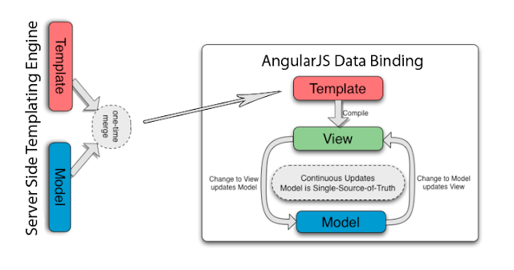](https://click.linksynergy.com/fs-bin/click?id=JVFxdTr9V80&subid=0&offerid=323058.1&type=10&tmpid=14538&RD_PARM1=https%3A%2F%2Fwww.udemy.com%2Fthe-complete-guide-to-angular-2%2F)](https://click.linksynergy.com/fs-bin/click?id=JVFxdTr9V80&subid=0&offerid=323058.1&type=10&tmpid=14538&RD_PARM1=https%3A%2F%2Fwww.udemy.com%2Fthe-complete-guide-to-angular-2%2F" \t "_blank)

Since it’s a JavaScript library, You can include this on your HTML page using the <script> tag. It extends HTML attributes with Directives and binds data to HTML using Expressions.

Since Google is behind Angular, you can rest assured in terms of performance and regular updates. I strongly believe AngularJS is here for the long run, hence, investing time in it is completely justified. If you decide to learn Angular in 2019, then [**Angular 5 — The Complete Guide**](https://click.linksynergy.com/fs-bin/click?id=JVFxdTr9V80&subid=0&offerid=323058.1&type=10&tmpid=14538&RD_PARM1=https%3A%2F%2Fwww.udemy.com%2Fthe-complete-guide-to-angular-2%2F) from Udemy is a good starting point.

**2) Node JS**

There is no doubt that JavaScript is the #1 programming language and Node.js has a big part to play in that. Traditionally, JavaScript is used as a client-side scripting language, where it is used with HTML to provide dynamic behavior on the client side. It runs on the web browser, but Node.js allows you to run JavaScript on the server side.

The Node.js is an open-source, cross-platform JavaScript run-time environment for executing JavaScript code server-side. You can use Node.js to create dynamic web pages on the server side before you send them to the client.

[[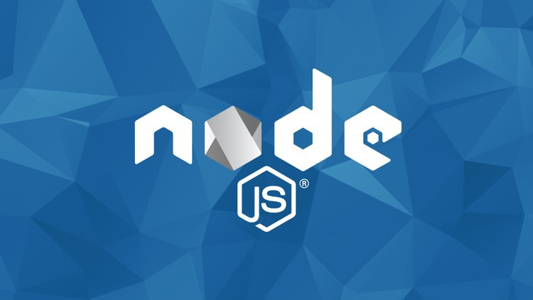](https://click.linksynergy.com/fs-bin/click?id=JVFxdTr9V80&subid=0&offerid=323058.1&type=10&tmpid=14538&RD_PARM1=https%3A%2F%2Fwww.udemy.com%2Fthe-complete-nodejs-developer-course-2%2F)](https://click.linksynergy.com/fs-bin/click?id=JVFxdTr9V80&subid=0&offerid=323058.1&type=10&tmpid=14538&RD_PARM1=https%3A%2F%2Fwww.udemy.com%2Fthe-complete-nodejs-developer-course-2%2F" \t "_blank)

This means you can develop a front to back, client-server application in JavaScript. I purchased [**The Complete Node.js Developer Course**](https://click.linksynergy.com/fs-bin/click?id=JVFxdTr9V80&subid=0&offerid=323058.1&type=10&tmpid=14538&RD_PARM1=https%3A%2F%2Fwww.udemy.com%2Fthe-complete-nodejs-developer-course-2%2F) last month on Udemy’s $10 sale and I look forward to learning it in 2019.

**3) Spring Boot**

I have been using the Spring framework for many years, so when I was first introduced to Spring Boot, I was totally surprised by the relative lack of configuration. Writing a Spring-based Java application using Spring Boot was as simple as writing a core Java application using the [main()](http://www.java67.com/2014/02/can-you-run-java-program-without-main-method.html) method.

Even though I have tried Spring Boot, I have yet to learn many things, and that’s why it’s on [my list of things to learn in 2019](https://javarevisited.blogspot.com/2017/12/10-things-java-programmers-should-learn.html#axzz53ENLS1RB).

[[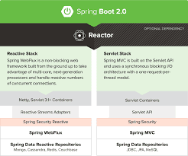](https://click.linksynergy.com/fs-bin/click?id=JVFxdTr9V80&subid=0&offerid=323058.1&type=10&tmpid=14538&RD_PARM1=https%3A%2F%2Fwww.udemy.com%2Fspring-boot-intro%2F)](https://click.linksynergy.com/fs-bin/click?id=JVFxdTr9V80&subid=0&offerid=323058.1&type=10&tmpid=14538&RD_PARM1=https%3A%2F%2Fwww.udemy.com%2Fspring-boot-intro%2F" \t "_blank)

I have also bought the [**Spring Boot Masterclass**](https://click.linksynergy.com/fs-bin/click?id=JVFxdTr9V80&subid=0&offerid=323058.1&type=10&tmpid=14538&RD_PARM1=https%3A%2F%2Fwww.udemy.com%2Fspring-boot-intro%2F), one of the best online courses to learn Spring Boot, from Udemy for just $10 last month, and I look forward to using that in 2019.

**4) React**

React is another JavaScript library or framework for building user interfaces. It’s like [Angular](http://www.java67.com/2018/01/top-5-free-angular-js-online-courses-for-web-developers.html) but maintained by Facebook, Instagram, and a community of individual developers and corporations. It allows web developers to create large web-applications which can change over time without reloading the page.

The web development world is divided between [Angular](https://javarevisited.blogspot.com/2018/06/top-10-angular-tutorials-and-courses-for-web-developers.html#axzz5Ie75bPFF) and [React](http://www.java67.com/2018/02/5-free-react-courses-for-web-developers.html) and it’s up to you what you choose. Most of the time, it’s dictated by circumstances; for example, if you are working in a React-based project, then obviously, you need to learn React.

[[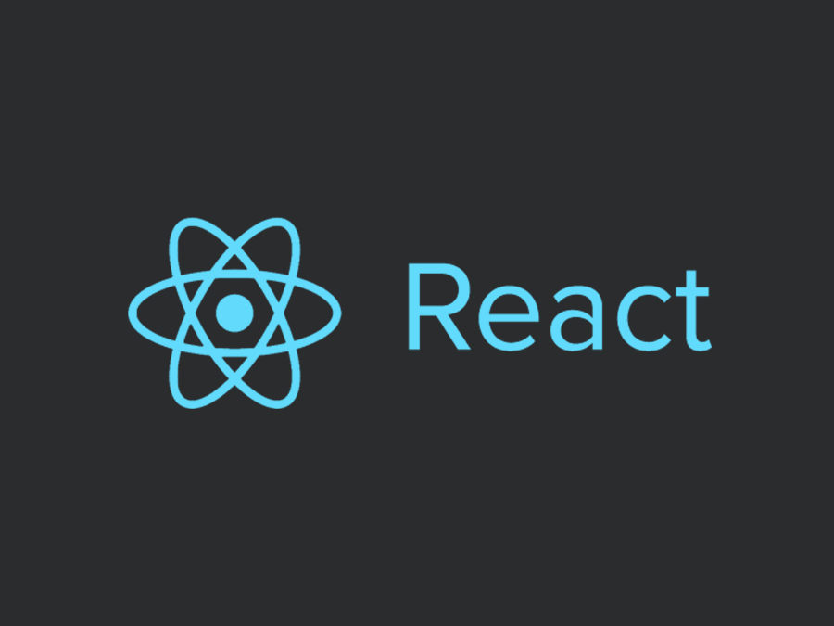](https://pluralsight.pxf.io/c/1193463/424552/7490?u=https%3A%2F%2Fwww.pluralsight.com%2Fcourses%2Freact-js-getting-started)](https://pluralsight.pxf.io/c/1193463/424552/7490?u=https%3A%2F%2Fwww.pluralsight.com%2Fcourses%2Freact-js-getting-started" \t "_blank)

If you decide to learn to React in 2019, then the [**React.js: Getting Started**](https://pluralsight.pxf.io/c/1193463/424552/7490?u=https%3A%2F%2Fwww.pluralsight.com%2Fcourses%2Freact-js-getting-started)course from Pluarlsight is a good starting point.

**5) Bootstrap**

This is another popular open-source, front-end web framework for designing websites and web applications. Initially brought to us by Twitter, Bootstrap provides HTML- and CSS-based design templates for typography, forms, buttons, navigation, and other interface components, as well as optional JavaScript extensions.

[[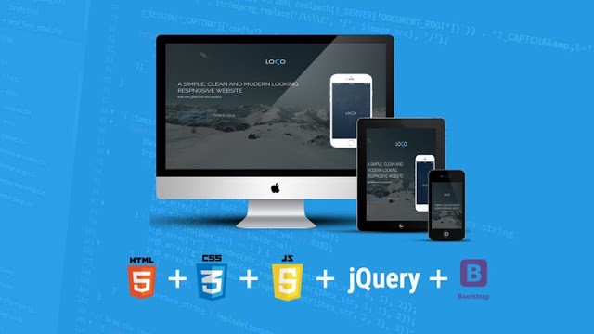](https://click.linksynergy.com/fs-bin/click?id=JVFxdTr9V80&subid=0&offerid=323058.1&type=10&tmpid=14538&RD_PARM1=https%3A%2F%2Fwww.udemy.com%2Fbootstrap-4-from-scratch-with-5-projects%2F)](https://click.linksynergy.com/fs-bin/click?id=JVFxdTr9V80&subid=0&offerid=323058.1&type=10&tmpid=14538&RD_PARM1=https%3A%2F%2Fwww.udemy.com%2Fbootstrap-4-from-scratch-with-5-projects%2F" \t "_blank)

Bootstrap supports responsive web design, which means the layout of web pages adjusts dynamically depending upon the browser’s screen size.

In the world of mobile, BootStrap is leading the way with its mobile-first design philosophy, emphasizing on a responsive design by default.

If you are a web developer and don’t know Bootstrap, 2019 is the right time to get started with it. **[BootStrap 4 From Scratch](https://click.linksynergy.com/fs-bin/click?id=JVFxdTr9V80&subid=0&offerid=323058.1&type=10&tmpid=14538&RD_PARM1=https%3A%2F%2Fwww.udemy.com%2Fbootstrap-4-from-scratch-with-5-projects%2F" \t "_blank)**is a good starting point for your Bootstrap journey in 2019.

**6) jQuery**

This is another JavaScript framework which rules the world. jQuery has been my favourite for a long time and I advise every developer to [learn jQuery](http://www.java67.com/2018/04/top-5-free-jquery-courses-for-web-developers.html). It makes client-side scripting really easy.

You can do animation, send HTTP request, reload pages, and perform client-side validation by writing just a couple of lines of code.

[[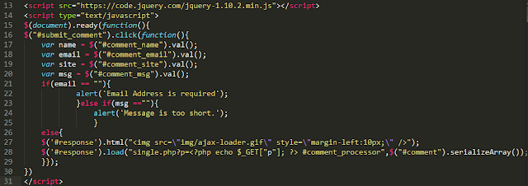](https://click.linksynergy.com/fs-bin/click?id=JVFxdTr9V80&subid=0&offerid=323058.1&type=10&tmpid=14538&RD_PARM1=https%3A%2F%2Fwww.udemy.com%2Fjquery-tutorial%2F)](https://click.linksynergy.com/fs-bin/click?id=JVFxdTr9V80&subid=0&offerid=323058.1&type=10&tmpid=14538&RD_PARM1=https%3A%2F%2Fwww.udemy.com%2Fjquery-tutorial%2F" \t "_blank)

If you decide to learn jQuery in 2019, then I suggest you take a look at this [**jQuery master class**](https://click.linksynergy.com/fs-bin/click?id=JVFxdTr9V80&subid=0&offerid=323058.1&type=10&tmpid=14538&RD_PARM1=https%3A%2F%2Fwww.udemy.com%2Fjquery-tutorial%2F)**,**a free online course from Udemy for learning jQuery.

**7) Spring Security 5**

There is no substitute for security, and in 2019, it will be even more important. Since Spring Security has become synonymous with web security in the Java world, it makes perfect sense to update yourself with the latest release of Spring Security in 2019.

[[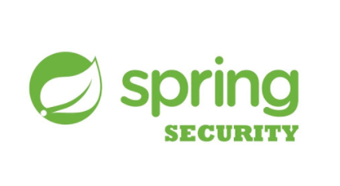](https://courses.baeldung.com/p/learn-spring-security-the-master-class?utm_source=javarevisited&utm_medium=web&utm_campaign=lss&affcode=22136_bkwjs9xa)](https://courses.baeldung.com/p/learn-spring-security-the-master-class?utm_source=javarevisited&utm_medium=web&utm_campaign=lss&affcode=22136_bkwjs9xa" \t "_blank)

The new version 5.0 of Spring Security includes many bug fixes and a complete new OAuth 2.0 module. Even if you don’t know Spring Security, you should consider learning it in 2019, and there is no better way than joining Eugen Paraschiv’s [**Learn Spring Security MasterClass**](https://courses.baeldung.com/p/learn-spring-security-the-master-class?utm_source=javarevisited&utm_medium=web&utm_campaign=lss&affcode=22136_bkwjs9xa)**.**

**8) Apache Hadoop**

Big Data and automation are the focus of many companies in 2019, and that’s why it becomes important for programmers to learn Big Data technologies like [Hadoop](http://www.java67.com/2018/05/top-5-free-big-data-courses-to-learn-Hadoop-Apache-Spark.html) and [Spark](http://www.java67.com/2018/04/5-free-apache-spark-course-for-java-scala-python-developers.html). Apache Hadoop is a framework which allows distributed processing of large data sets across clusters of computers using simple programming models.

[[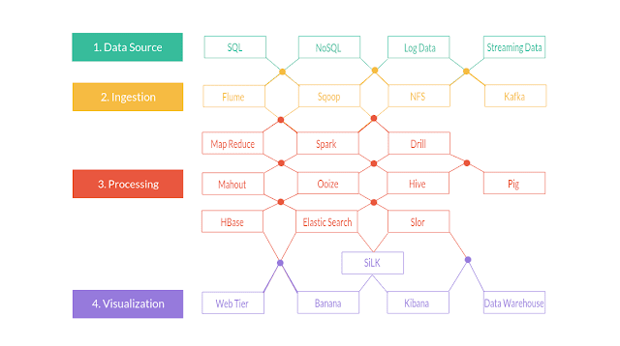](https://click.linksynergy.com/fs-bin/click?id=JVFxdTr9V80&subid=0&offerid=323058.1&type=10&tmpid=14538&RD_PARM1=https%3A%2F%2Fwww.udemy.com%2Fthe-ultimate-hands-on-hadoop-tame-your-big-data%2F)](https://click.linksynergy.com/fs-bin/click?id=JVFxdTr9V80&subid=0&offerid=323058.1&type=10&tmpid=14538&RD_PARM1=https%3A%2F%2Fwww.udemy.com%2Fthe-ultimate-hands-on-hadoop-tame-your-big-data%2F" \t "_blank)

It is designed to scale up from single servers to thousands of machines, each offering local computation and storage. It’s based upon the popular [Map Reduce pattern](http://www.java67.com/2016/09/map-reduce-example-java8.html) and is key for developing a reliable, scalable, and distributed software computing application.

I have already enrolled in [**The Ultimate Hands-On Hadoop**](https://click.linksynergy.com/fs-bin/click?id=JVFxdTr9V80&subid=0&offerid=323058.1&type=10&tmpid=14538&RD_PARM1=https%3A%2F%2Fwww.udemy.com%2Fthe-ultimate-hands-on-hadoop-tame-your-big-data%2F) last month, and if you decide to learn Hadoop in 2019, you can join, too, on Udemy.

**9) Apache Spark**

This is another Big Data framework which is gaining popularity. Apache Spark is a fast, in-memory data processing engine with elegant and expressive development APIs to allow data workers to efficiently execute streaming, machine learning, or SQL workloads that require fast iterative access to datasets.

[[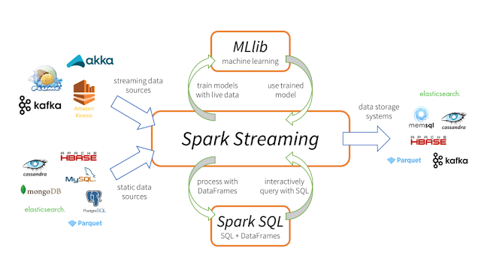](https://pluralsight.pxf.io/c/1193463/424552/7490?u=https%3A%2F%2Fwww.pluralsight.com%2Fcourses%2Fapache-spark-fundamentals)](https://pluralsight.pxf.io/c/1193463/424552/7490?u=https%3A%2F%2Fwww.pluralsight.com%2Fcourses%2Fapache-spark-fundamentals" \t "_blank)

You can use Spark for in-memory computing for ETL, machine learning, and data science workloads to Hadoop. I have already shortlisted the [**Apache Spark Fundamentals**](https://pluralsight.pxf.io/c/1193463/424552/7490?u=https%3A%2F%2Fwww.pluralsight.com%2Fcourses%2Fapache-spark-fundamentals) course from PluralSight to go through in 2019. If you are in the same boat, you can check out that course to get some inspiration.

**10) Cordova**

Apache Cordova is another mobile application development framework originally created by Nitobi. Adobe Systems purchased Nitobi in 2011, rebranded it as PhoneGap, and later released an open source version of the software called Apache Cordova.

[[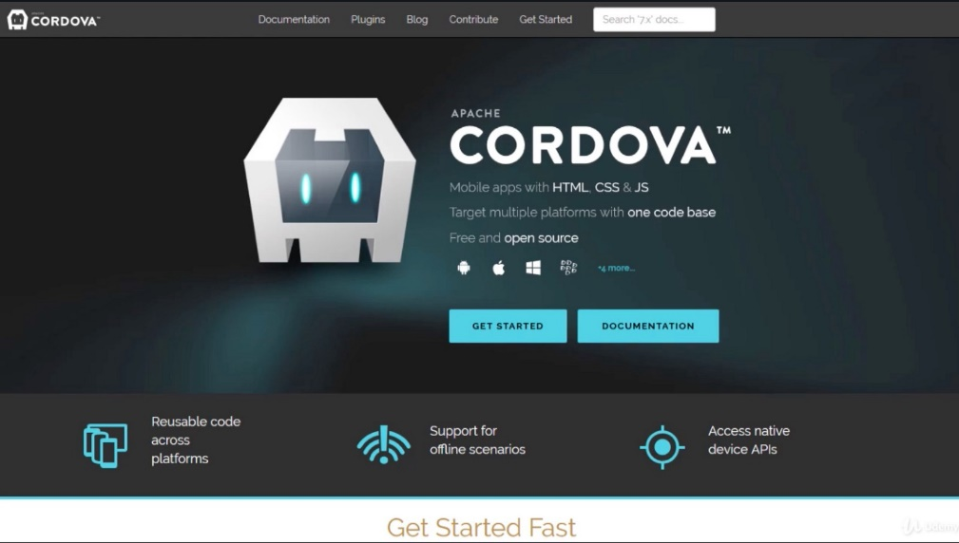](https://click.linksynergy.com/fs-bin/click?id=JVFxdTr9V80&subid=0&offerid=323058.1&type=10&tmpid=14538&RD_PARM1=https%3A%2F%2Fwww.udemy.com%2Fionic-2-the-practical-guide-to-building-ios-android-apps%2F)](https://click.linksynergy.com/fs-bin/click?id=JVFxdTr9V80&subid=0&offerid=323058.1&type=10&tmpid=14538&RD_PARM1=https%3A%2F%2Fwww.udemy.com%2Fionic-2-the-practical-guide-to-building-ios-android-apps%2F" \t "_blank)

It allows you to use standard web technologies — HTML5, CSS3, and JavaScript for cross-platform development, and one is of the hot technologies to learn in 2019.

If you’d like to learn Cordova in 2019, then please check out [**Build iOS & Android Apps with Angular and Cordova**](https://click.linksynergy.com/fs-bin/click?id=JVFxdTr9V80&subid=0&offerid=323058.1&type=10&tmpid=14538&RD_PARM1=https%3A%2F%2Fwww.udemy.com%2Fionic-2-the-practical-guide-to-building-ios-android-apps%2F)**,** one of the exciting courses for learning Cordova.

**11) Firebase**

Firebase is Google’s mobile platform that helps you quickly develop high-quality mobile apps and grow your business. You can choose Firebase as a backend for your Android or iOS application.

[[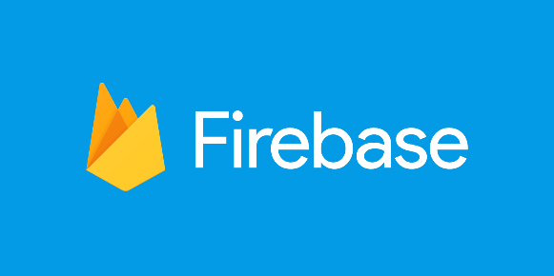](https://click.linksynergy.com/fs-bin/click?id=JVFxdTr9V80&subid=0&offerid=323058.1&type=10&tmpid=14538&RD_PARM1=https%3A%2F%2Fwww.udemy.com%2Fadvanced-ios-firebae-build-an-uber-clone-app%2F)](https://click.linksynergy.com/fs-bin/click?id=JVFxdTr9V80&subid=0&offerid=323058.1&type=10&tmpid=14538&RD_PARM1=https%3A%2F%2Fwww.udemy.com%2Fadvanced-ios-firebae-build-an-uber-clone-app%2F" \t "_blank)

If you are looking to move into the lucrative business of mobile application development in 2019, then learning Firebase is a very good idea and [**Advanced iOS and Firebase: Rideshare**](https://click.linksynergy.com/fs-bin/click?id=JVFxdTr9V80&subid=0&offerid=323058.1&type=10&tmpid=14538&RD_PARM1=https%3A%2F%2Fwww.udemy.com%2Fadvanced-ios-firebae-build-an-uber-clone-app%2F)is a good place to start.

**12) Xamarin**

Xamarin is a way to make mobile apps quickly for all platforms with a single, shared C# code base, build a custom native user interface for each platform, or use Xamarin.Forms to write a single shared user interface across platforms.

It’s owned by Microsoft and quickly becoming popular for creating mobile apps for C, C++, and C# developers.

[[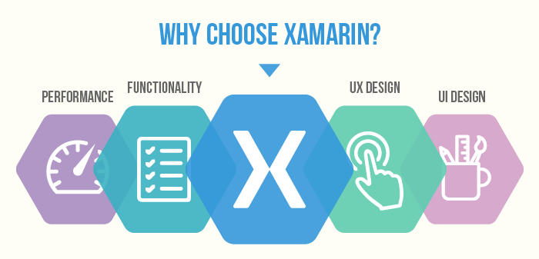](http://bit.ly/2DxBRt4)](http://bit.ly/2DxBRt4" \t "_blank)

If you already know one of the C languages and you’re looking for a career in mobile app development, then I strongly suggest you learn Xamarin in 2019, and [**The Complete Xamarin Developer Course: iOS And Android!**](http://bit.ly/2DxBRt4)is a good course to start with.

That’s all about what to learn in 2019. These frameworks are in great demand, particularly Spring, Node.js, and AngularJS. Learning these frameworks will not only improve your chances of getting a job but also open many doors of opportunity.